
Consistory of Ancient and Accepted Scottish-Rite
Commander in Chief
ILL:. B:. Gerald Walker 33°
Deputy, Commander
ILL:. B:. Roderic DeSouza 33°
Officers to be commissioned
1st Lt. Commander
2nd Lt. Commander
Grand Orator
Grand Chancellor
Grand Master of Ceremonies
Grand Treasure
Grand Secretary
Grand Standard Bearer
Grand Hospitaller
Grand Architect & Engineer
Grand Captain of the Guard
Grand Tiler

This is a formal alarm to order. I pray the Grand Architect of the Universe grant peace, and the blessings upon your household. I am writing to inform you of the first meeting for the Lodge of Perfection will be held on:
“Septuagestima Sunday” February 20th 2011
Location: The New Masonic Training Center
2021 W. North Ave
Baltimore MD, 21217

Start Time: 2/20/2011 12:00 Noon
End Time: 2/20/2011 3:00 PM

Meeting
Agenda:
- Introduction to the New Training Center
- Consistory Charter :
- Membership Role Call:
- 2011 Calendar:
- Website Access:
- Officer Placement:
- Annual dues:
Additionally, all members of the jurisdiction holding degrees above master mason will be required to provide current contact information at this meeting. Please pass this Alarm to any and all members of our jurisdiction; all are welcome to the Introduction to the Masonic Training Center portion of our meeting.
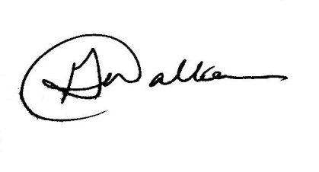
Fraternally,

Ill:. B:. Gerald Walker 33°
Commander in Chief

